Workflow
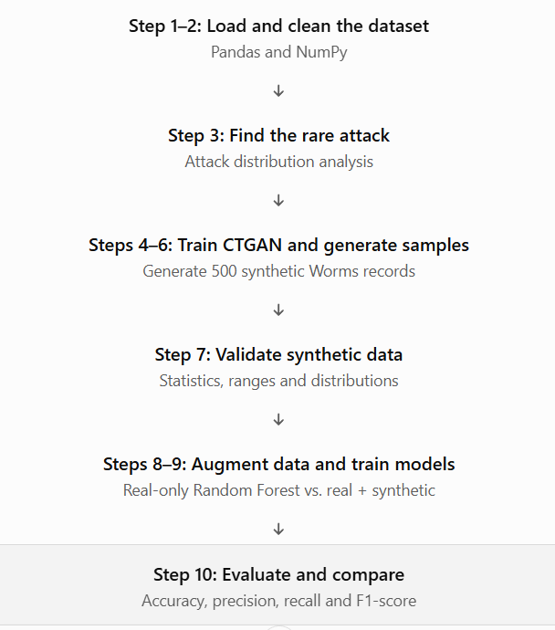

Explanation
Step 1 — Import libraries and load the dataset
What you did: Loaded the UNSW-NB15 CSV files using Pandas and imported NumPy and Matplotlib.
- Pandas: Loads and manipulates tabular data.
- NumPy: Handles numerical operations.
- Matplotlib: Creates graphs.
First, we load the UNSW-NB15 network intrusion dataset. It contains network traffic features and labels that identify normal traffic and different types of attacks.
The dataset includes features such as protocol, packet counts, byte counts, connection duration, and attack category.

Step 2 — Data preprocessing
What you did: Checked missing values, duplicate records, column data types, and target labels. Then removed duplicate records and rows without attack labels.
Why: Poor-quality or incomplete data can affect the training process.
In preprocessing, we inspect the dataset and remove duplicate records and rows that do not have the required target labels.

Step 3 — Analyze attack distribution
What you did: Counted the records in each attack category and plotted a bar graph.
Your earlier output showed that Worms had only 44 records in the training data used for your experiment, making it the rarest category.
Why: A model trained on imbalanced data may learn common attack categories better than rare ones.
We analyze the attack distribution to identify which attack category has the fewest samples. In our experiment, the rarest category was Worms, so we selected it for synthetic data generation.

Step 4 — Install and import CTGAN
What you did: Installed SDV, the Synthetic Data Vault library, and imported CTGAN Synthesizer.
What is CTGAN? CTGAN stands for Conditional Tabular Generative Adversarial Network. It learns patterns from tabular data and generates artificial records that resemble the original data.
We use CTGAN because our dataset is tabular. It learns the feature patterns of rare attack records and generates additional artificial records to help address the class imbalance.

Step 5 — Prepare the rare attack data and train CTGAN
What you did:
- Selected only records belonging to the rare Worms category.
- Removed the id, attack_cat, and label columns from the CTGAN input.
- Prepared numerical and categorical columns.
- Corrected the metadata so that state is categorical and ct_state_ttl is numerical.
- Trained CTGAN for 50 epochs.
Why remove those three columns? The ID is an identifier, while attack_cat and label are target information. The model learns the traffic features; the target labels are restored after generation.
We train CTGAN on the real Worms traffic records only. We correct the column types because incorrect metadata can cause invalid synthetic values. We train the model for 50 epochs so it can learn patterns from the selected records.

Step 6 — Generate synthetic rare samples
What you did: Generated 500 synthetic records and assigned their target values:
- attack_cat = "Worms"
- label = 1
Why: The original dataset has very few Worms samples. The generated records increase the representation of that category during classifier training.
After training CTGAN, we generate 500 artificial Worms traffic records. We assign the corresponding attack label so that these records can be included in the augmented training dataset.
Important: These are synthetic records, not 500 newly observed real attacks.
Step 7 — Validate synthetic data
This step checks whether the generated data is numerically reasonable and resembles the real rare-attack data.
You compared:
- Mean — the average value of a feature.
- Standard deviation — how much the feature values vary.
- Minimum and maximum — the observed feature ranges.
- Missing and infinite values.
- A histogram comparing the real and synthetic dur feature.
Your latest check reported 500 synthetic records, zero missing numeric values, and zero infinite numeric values.
We validate the generated data by comparing its statistical properties with the real Worms records. We also check missing values, infinite values, and feature ranges. This helps us identify potential data-quality issues before training the classifier.

Step 8 — Prepare real-only and augmented datasets
What you did: Created two training datasets.
- Real-only dataset: The original real training records.
- Augmented dataset: The original real training records combined with 500 synthetic records.
Output was:
Dataset | Number of records
Real training data | 175,341
Synthetic data | 500
Augmented training data | 175,841
We create two experimental datasets. The first contains only real records, and the second contains real records plus 500 synthetic Worms records. This allows us to measure the effect of synthetic data on intrusion detection.
Step 9 — Train two Random Forest classifiers
What you did: Trained two Random Forest models, one on each dataset.
A Random Forest combines multiple decision trees to make predictions.
Your code also uses:
- OneHotEncoder to convert categorical features into a numerical representation.
- SimpleImputer to handle missing feature values.
- ColumnTransformer to apply the appropriate preprocessing to numerical and categorical columns.
- class_weight="balanced" to account for class imbalance.
We train two Random Forest classifiers using the same model configuration. One uses only real training data, and the other uses augmented training data. We keep the test dataset separate so we can compare their performance fairly.

Step 10 — Compare model performance
Evaluated both models using accuracy, macro precision, macro recall, macro F1-score, and the classification report.
Recorded overall results were:
Metric | Real only | Real + synthetic
Accuracy | 74.81% | 75.00%
Macro precision | 52.55% | 52.71%
Macro recall | 51.13% | 51.71%
Macro F1-score | 48.38% | 48.07%

The Worms-specific results were:
Worms metric | Real only | Real + synthetic
Correctly detected | 5 of 44 | 7 of 44
Recall | 11.36% | 15.91%
F1-score | 0.2041 | 0.2745

The augmented model detected seven Worms samples compared with five for the real-only model. Worms recall increased from approximately 11.36% to 15.91%. However, overall macro F1-score decreased slightly. Therefore, synthetic augmentation improved Worms detection in this experiment, but it did not improve every metric.

